CRUD Final Project
Web Programming (CIT-215)
Nathan Brunner

The data I used for this project is based on my personal Lego collection, so I created an array named “collection”, stored it in a JavaScript file named collection.js, and spent a couple days adding information and images for each set by having an object dedicated to each set. This array contains a total of 98 sets, each with the following properties: name; set number; release year; number of pieces; whether it’s retired; retail value; market value; theme; subtheme; and image. All the images are stored in a sub folder named “images” and renamed each image to be the set number + .png.
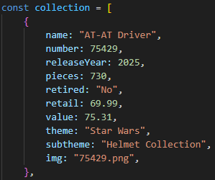
collection.js; lines 1 - 13

When I created the HTML file, index.html, I also added the most recent version of the jQuery library, jquery-3.7.1.js, to the same folder. Under the title element, I added three script tags with the sources, in order: jquery-3.7.1.js; collection.js; and app,js. I then created the app.js file to give the web page its functionality.
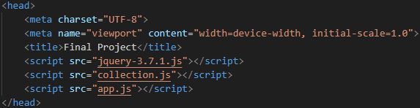
index.html; lines 3 - 10

Most of the CSS styling is implemented in the index.html file using style tags before the body tags.
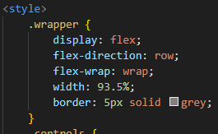
index.html; lines 11 – 18
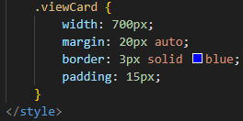
index.html; lines 66 - 71

I then added content in the body tags of the HTML file to give it structure as shown in the screenshot below. This includes: header; h1; div; select; option; and button.
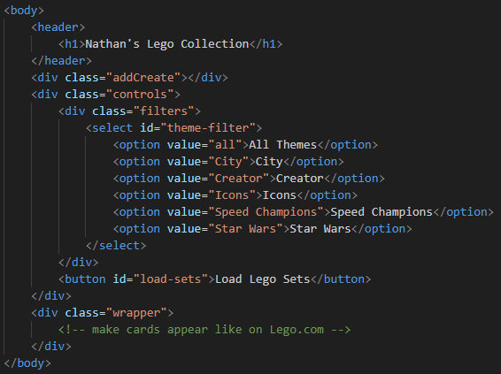
index.html; lines 73 - 94

The filter tags, everything initially contained in the div tag with class “controls” were not necessary for this project, but it added functionality to make the appearance of all the data on the web page easier to view as the user sees fit. The purpose of the div tag with class “wrapper” is to contain the individual cards that are used to display the data stored in the collections.js file.
In the app.js file, I first defined an arrow function named “setup” to be a callback function and outside of the function, used jQuery to make the “setup” function run after the DOM has fully loaded. This “setup” function starts with a couple of console.log function calls to display in the console that the “setUp” function is running and data stored in the collection.js file is accessible. It then clears any content within the div tag with class “wrapper” to then run a function named “cardFunc” with the argument “collection” to pass the array stored in the collection.js file, which creates the cards that display information for each object. The function then implements a jQuery click event handler for the button tag in the HTML file with id “load-sets” so when that button is clicked it will call a function named “filterFunc” apply the functionality of the filter options. The last part of the “setUp” function calls a function named “mouseActionFunc” to apply the actions of interacting with the displayed cards.
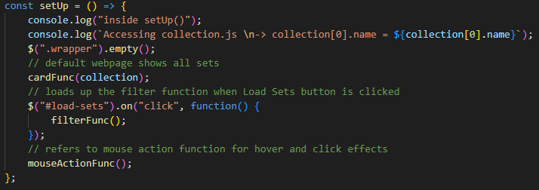
app.js; lines 11 - 23
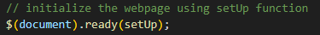
app.js; lines 301 - 302

The “cardFunc” arrow function passes through a parameter stored as “array” which, as mentioned earlier, refers to the array “collection” stored in the collection.js file. The first line is a console.log function that displays “Inside cardFunc()” in the console to show that the “cardFunc” function is running. The next line clears out any content within in the div tag with class “wrapper”. Using the forEach method on the parameter “array”, each object stored in “array” is referred to as “set” to first, show in the console that the object running through this method, and then it creates the HTML that is used to structure each card and then appends it to the div tag with class “wrapper”. The HTML structure for each card includes a div tag with class “card”, which contains everything that follows, a div tag with class “image_container”, which contains the img tag for the object’s image, a div tag with class “content”, which contains the tags that call the object’s name, set number, release year, number of pieces, retail value, and market value.
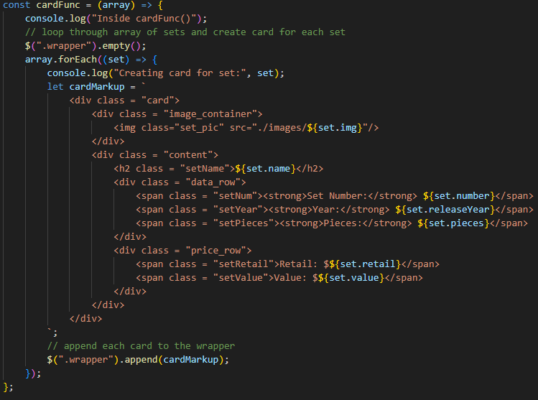
app.js; lines 25 - 53
The “filterFunc” arrow function runs when the button tag with id “load-sets” is clicked in the “setup” function. It first runs the same line as before to clear the div tag with class “wrapper”. Next it grabs the value stored in the select tag with id “theme-filter” which can one of the following from the option tags: all; City; Creator; Icons; Speed Champions; and Star Wars, then stores it in a variable named “selectedTheme”. The following line shows in the console the value of “selectedTheme”. A new, empty array named “filtereSets” is then defined. An if…else condition is then used to push all objects from the “collection” array into the “filteredSets” array if the value of “selectedTheme” is “all”, otherwise the else statement uses a forEach method to run through each object in the “collection” array to check the “theme” property is equal to the value stored in “selectedTheme” using an if statement. If the condition is true, then that object is pushed to the “fileteredSets” array. The console then shows all the objects stored in “filteredSets” and provides the length of the “filteredSets” array. The “cardFunc” function is then called with “fileteredSets” as an argument, which creates and displays a card on the web page for each object in “filteredSets”. This is all done so that only the objects in the “collection” array with a specified property, theme, value is displayed on the web page. The “mouseActionFunc” function is then called to give the displayed cards actions of interacting with the cards.
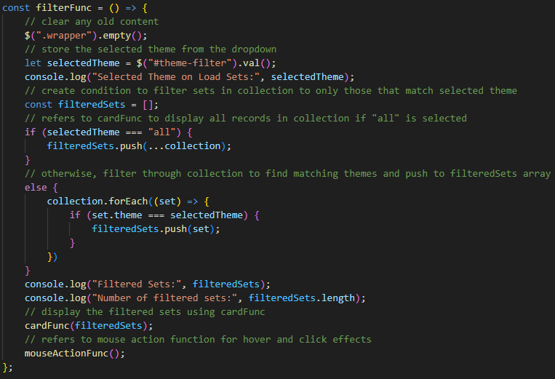
app.js; lines 55 - 81
The “mouseActionFunc” function first shows in the console that it is running. What follows is three jQuery event handlers for, hovering, stop hovering, and clicking actions. The hovering action refers to the div tag with class “card”, created in the “crardFunc” function, and uses the event handler mouseover to first show in the console that this event is running, then applies CSS styling dynamically to give the card a shadow when the mouse hovers over it. The stop hovering action is necessary because without it the shadow from the hovering action will not disappear when the mouse is moved out of the card. That action also refers to the div tag with class “card” and uses the event handler mouseout to first show in the console that this event is running, then applies CSS styling dynamically to remove the shadow from the card. The last action, clicking, also refers to the div tag with class “card” and uses the event handler click to first show in the console the HTML of the div tag with class “card” and its content, which is referred to as “this”. The next line uses the find method to search for the HTML element with class “setNum” for the card that is clicked, then uses the text method to get the content in that HTML element to be stored as a string, then uses the split method splits the text into an array using spaces to separate each element, then extracting the third element in the array, it’s saved in the variable “setNum”. The console then shows the value stored in “setNum”. The next line uses the findIndex method, which retrieves the index of the element that has the same value stored in the “number” property, from the objects in the “collection” array, as the value stored in the variable “setNum” and stores that index value in a variable named “index”. The console then shows the value of the variable “index”. The last line calls a function named “cardClickFunc” which passes the variable “index” as an argument. This entire click action event handler initiates the Read functionality of this program.
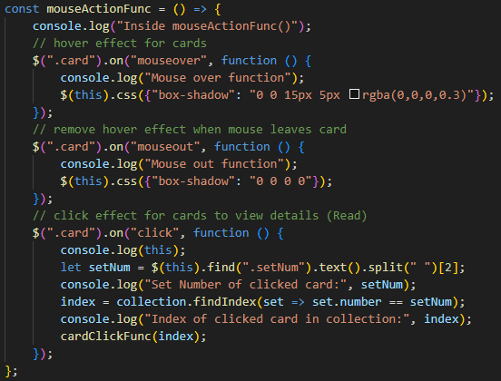
app.js; lines 83 - 104

This next function satisfies the Read aspect of CRUD (Create, Read, Update, Delete). The arrow function named “cardClickFunc”, which was called at the end of the click action event handler with the argument “index”, is then defined and passes through a parameter named “index”. The console shows that this function is being executed and provides the value stored in the parameter “index”. Just as before, the next line clears the div tag with class “wrapper”. The entire object of the set that was clicked is then stored in a variable named “viewSet” by referring to the specific object from the “collection” array using array indexing. The console then shows the data stored in the “viewSet” variable. A new variable named “detailMarkup” is then defined storing the HTML structure to display every property of the object stored in “viewSet”. “detailMarkup” is then appended to the div tag with class “wrapper”. Three click event handlers are created to give the button tags created in the HTML stored in “detailMarkup”, with the ids: “backButton”; “updateButton”; “deleteButton”, their appropriate functionality. The button tag with id “backButton” calls the “setUp” function, which takes the user back to the starting point, showing all the cards on the web page. The button tag with id “updateButton” calls the “updateHandler” function and passes the variable “index” as an argument. The button tag with id “deleteButton” calls the “deleteHandler” function and passes the variable “index” as an argument.
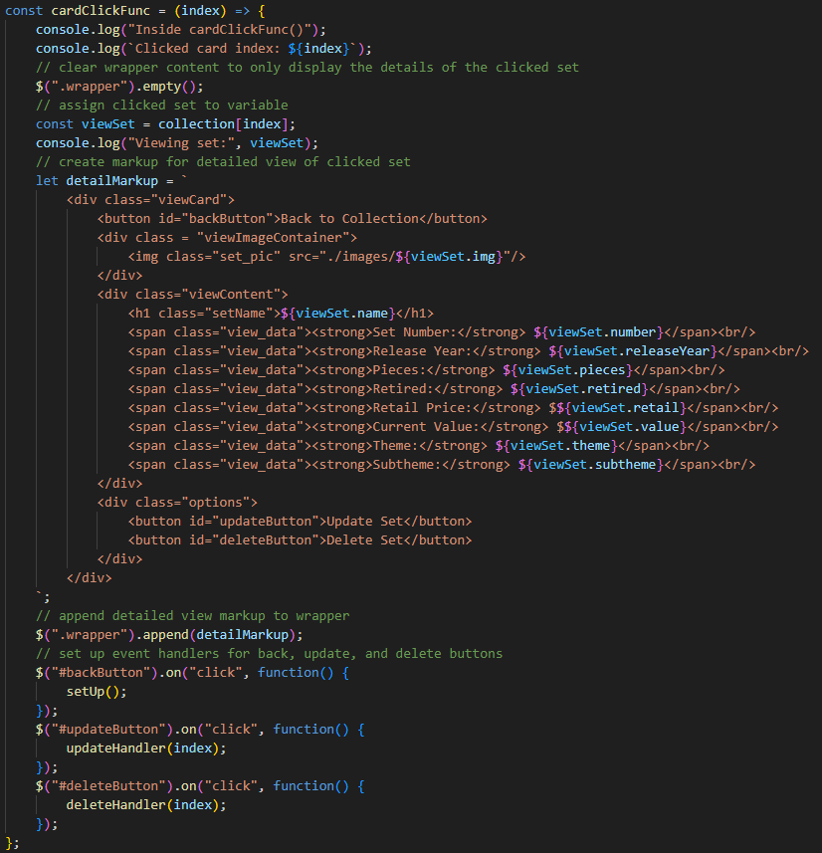
app.js; lines 108 – 152

The following function satisfies the Update aspect of CRUD. The “updateHandler” arrow function is defined with the parameter “index”. The console shows that this function is being executed. The div tag with class “viewContent”, which was created in the HTML structure from the “cardClickFunc” function, is stored in a variable named “displayLine”. The div tag with class “options”, which was also created in the HTML structure from the “cardClickFunc” function, is stored in a variable named “displayButtons”. A variable named “updatePara” is then defined, storing the HTML structure for the update form to receive inputs from the user for each property in the object. A variable named “updateButtons” is then defined to provide two button tags with ids “saveButton” and “cancelButton”. The next two lines replace the display area with the update form and the buttons. The first of the two lines calls “viewContent” class by using the html method with the variable “displayLine” to insert the HTML content in the “updatePara” variable onto the web page. The second of the two lines calls the “options” class by doing the same thing as the previous line but uses the variable “displayButtons” to insert the HTML content in the “updateButtons” variable onto the web page. A click event handler is then created for the button tag with id “saveButton” that takes the values inputted by the user from the update form and replaces properties of the original object stored in the “collection” array, except for the “img” property, which keeps the original value so that the image will remain the same. This event handler ends by calling the “cardClickFunc” function with “index” as an argument. Another click event handler is created for the button tag with id “cancelButton” which just calls the “cardClickFunc” function with “index” as an argument.
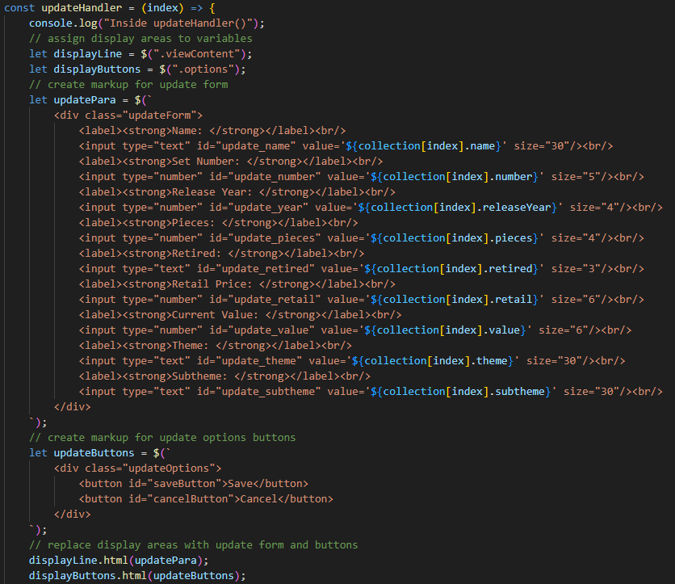
app.js; lines 155 – 192
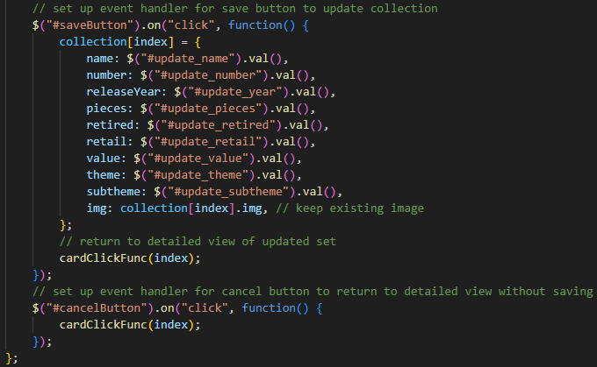
app.js; lines 193 – 214

The following function satisfies the delete aspect of CRUD. The arrow function named “deleteHandler” is created with the parameter “index”. The console shows that this function is executing. A variable named “set” is defined to store the object from the “collection” array that has the same index value as the index value of the div tag with class “viewContent” using the eq method. The console then shows the value of “set”. The object stored in “set” is then deleted from being displayed on the webpage by using the remove method. The next line then deletes the object in “set” from the “collection” array by using the splice method with the value stored in “index” and specified that it should only delete the one object from the array. The last line calls the “setUp” function to display all the cards except for the deleted one(s).
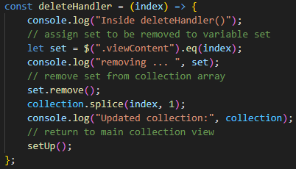
app.js; lines 217 – 228

Before discussing the “createHandler” function, I need to discuss the “createCreateButton” function. A separate function was created with the purpose of creating the create button that appears on the web page to avoid duplicate create buttons from appearing on the web page, which is what would happen if the button was created in the “setUp” function. This arrow function starts by defining a variable named “createPara” which stores the HTML structure for a button tag with class “create”. “createPara” is then added to the div tag with class “addCreate”, from the index.html, file by using the prepend method. CSS styling is then dynamically applied to the button tag with class “create”. A click event handler is created to give that same button tag functionality by calling the “createHandler” function. This function is initialized separately from the “setUp” function as shown in the second screenshot below.
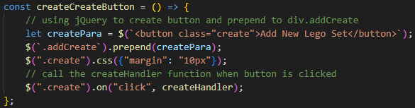
app.js; lines 2 - 9
app.js; line 305

The following function satisfies the create aspect of CRUD. An arrow function named “createHandler” is defined. The console shows that this function is executing. Then the button tag with class “create” is disabled using the prop method. A variable named “createPara” is defined to store the HTML structure to receive inputs from the user to eventually assign each property of the new object a value. This HTML includes two button tags with the classes “save_new” and “cancel_new”. The HTML in “createPara” is inserted onto the web page below the button tag with class “create” by using the after method. CSS styling is then dynamically added to make the create form appear separate from the rest of the web page to avoid confusing the user. A click event handler is created to give the button tag with id “save_new” functionality. It takes the values entered by the user and assigns them to the appropriate properties, except for the “img” property which will always display the sample.png for every created set and stores the properties in an object named “newSet”. The console then shows the value of “newSet”. “newSet” is added to the end of the “collection” array by using the push method. The “setUp” function is then called to show all the cards including the newly created set at the end of the original cards. The create form is then removed from the web page by using the remove method and the button with class “create” is re-enabled, which ends this click event handler. A second click event handler is created for the button tag with class “cancel_new” which removes the create form from the web page and re-enables the button tag with class “create”.
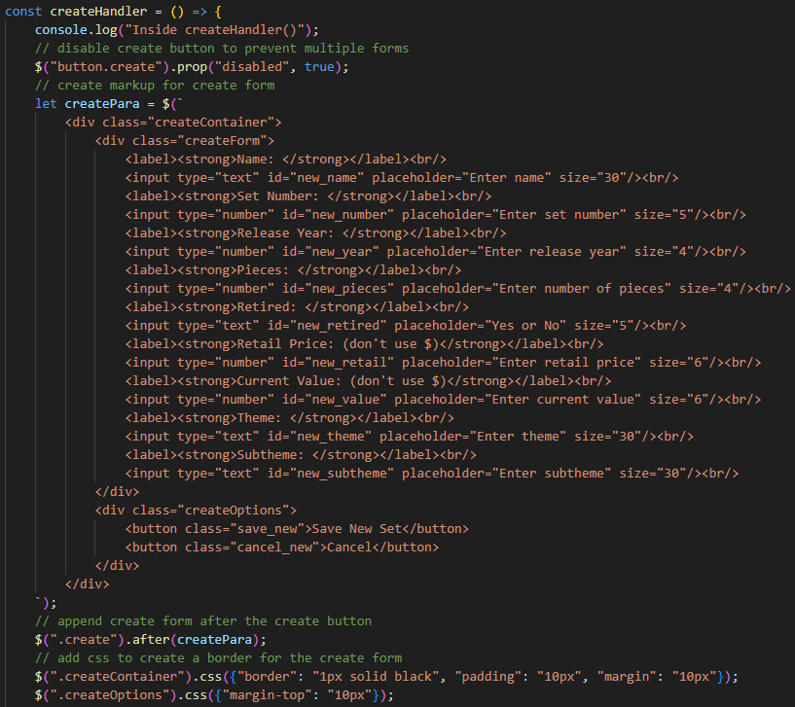
app.js; lines 231 - 268
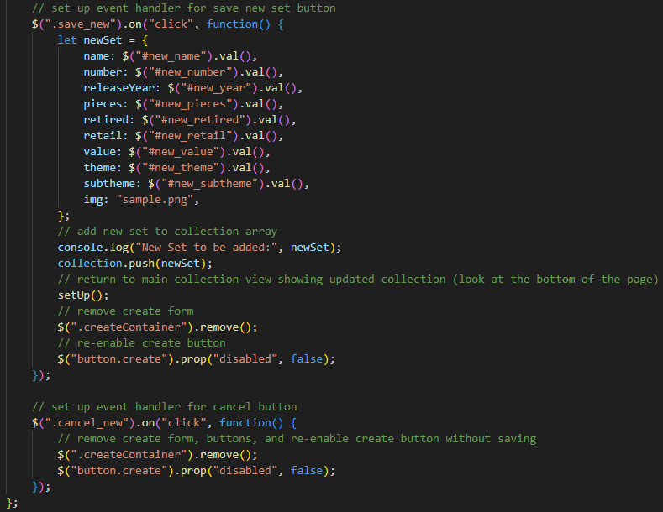
app.js; lines 269 - 300

